Lab Exercise 2– Terraform AWS Provider Configuration
Prerequisites: Terraform Installed: Make sure you have Terraform installed on your machine. Follow the official installation guide if needed.
Exercise Steps:

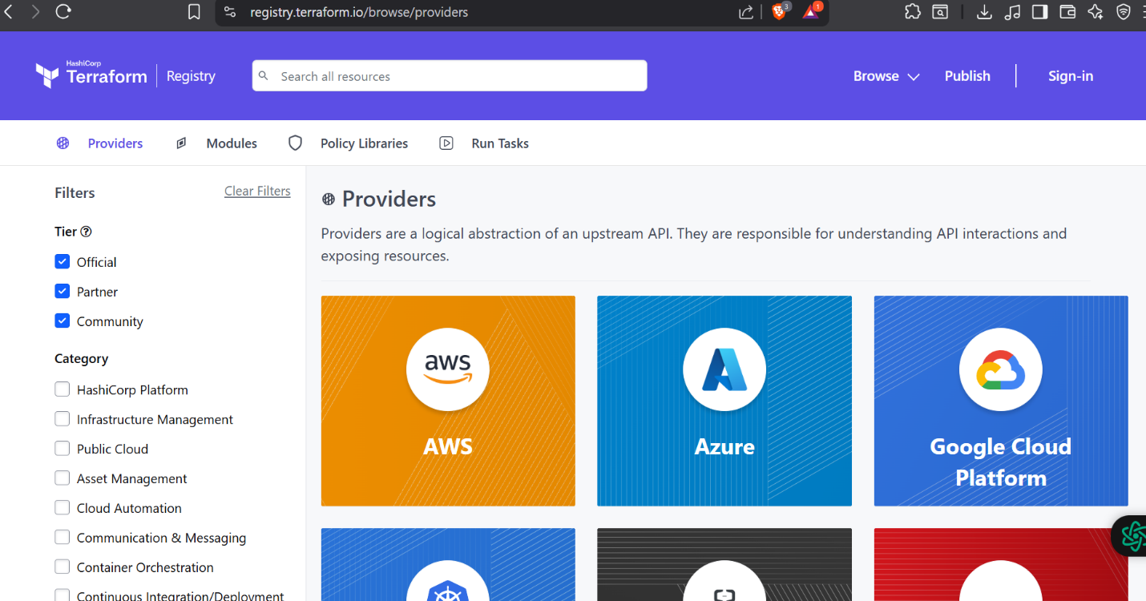
Step 1: Create a New Directory:
Create a new directory for your Terraform configuration:
“Terraform-Demo”
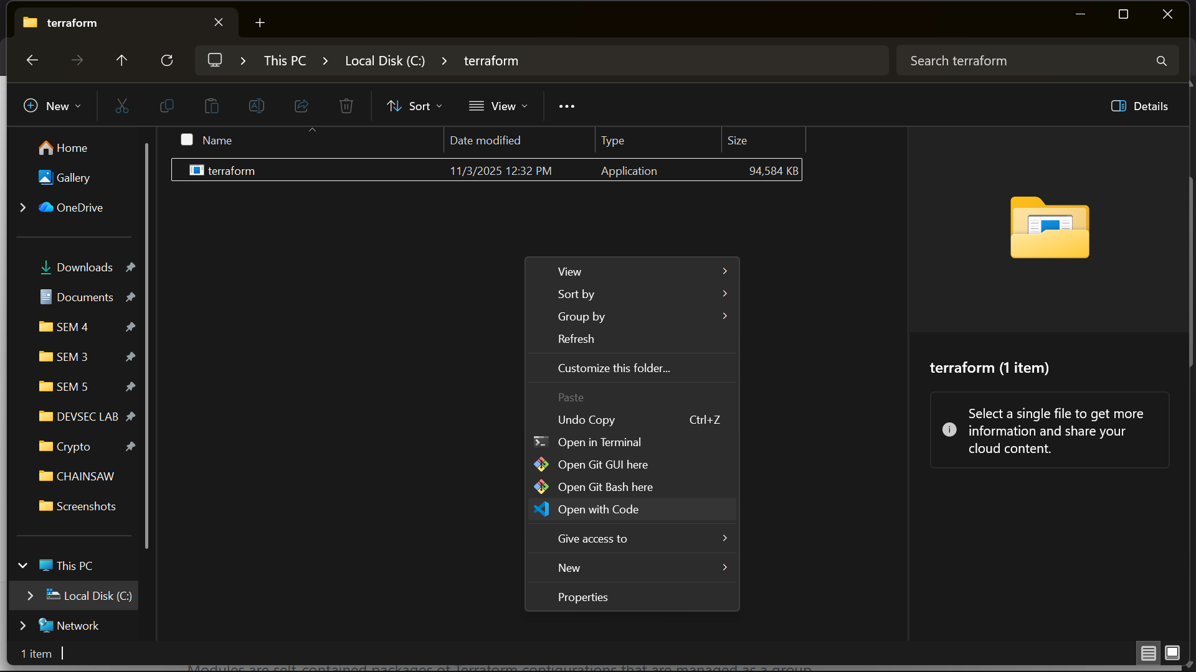

Step 2: Create Terraform Configuration File (main.tf):
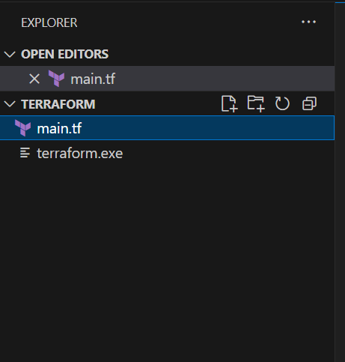
Create a file named main.tf with the following content:
terraform {
required_providers {
aws = {
source = "hashicorp/aws"
version = "6.19.0"
}
}
}

provider "aws" {

}

Step 3: Initialize Terraform:
Run the following command to initialize your Terraform working directory:
terraform init

